UNITED STATES
SECURITIES AND EXCHANGE COMMISSION
Washington, D.C. 20549
SCHEDULE 14A
Proxy Statement Pursuant to Section 14(a) of the
Securities Exchange Act of 1934
(Amendment No. )
Filed by the Registrant ☒ Filed by a Party other than the Registrant ☐
Check the appropriate box:
☐ Preliminary Proxy Statement
☐ Confidential, for Use of the Commission Only (as permitted by Rule 14a-6(e)(2))
☐ Definitive Proxy Statement
☒ Definitive Additional Materials
☐ Soliciting Material Pursuant to §240.14a-12
The Scotts Miracle-Gro Company

(Name of Registrant as Specified In Its Charter)

(Name of Person(s) Filing Proxy Statement, if other than the Registrant)
Payment of Filing Fee (Check all boxes that apply):
☒ |  |  | No fee required.
☐ |  |  | Fee paid previously with preliminary materials.
☐ |  |  | Fee computed on table in exhibit required by Item 25(b) per Exchange Act Rules 14a-6(i)(1) and 0-11.


Your Vote Counts! *Please check the meeting materials for any special requirements for meeting attendance. Smartphone users Point your camera here and vote without entering a control number For complete information and to vote, visit www.ProxyVote.com Control # V82165-P41545-Z91648 You invested in THE SCOTTS MIRACLE-GRO COMPANY and it’s time to vote! You have the right to vote on proposals being presented at the Annual Meeting. This is an important notice regarding the availability of proxy materials for the shareholder meeting to be held on January 26, 2026. Vote Virtually at the Meeting* January 26, 2026 9:00 a.m., Eastern Time Virtually at: www.virtualshareholdermeeting.com/SMG2026 Get informed before you vote View the Notice of Annual Meeting of Shareholders, Proxy Statement and 2025 Annual Report online OR you can receive a free paper or email copy of the material(s) by requesting prior to January 12, 2026. If you would like to request a copy of the material(s) for this and/or future shareholder meetings, you may (1) visit www.ProxyVote.com, (2) call 1-800-579-1639 or (3) send an email to sendmaterial@proxyvote.com. If sending an email, please include your control number (indicated below) in the subject line. Unless requested, you will not otherwise receive a paper or email copy. THE SCOTTS MIRACLE-GRO CO. ATTN: KATHY UTTLEY — PARALEGAL 14111 SCOTTSLAWN ROAD MARYSVILLE, OH 43041 THE SCOTTS MIRACLE-GRO COMPANY 2026 Annual Meeting Vote by January 25, 2026 11:59 PM ET

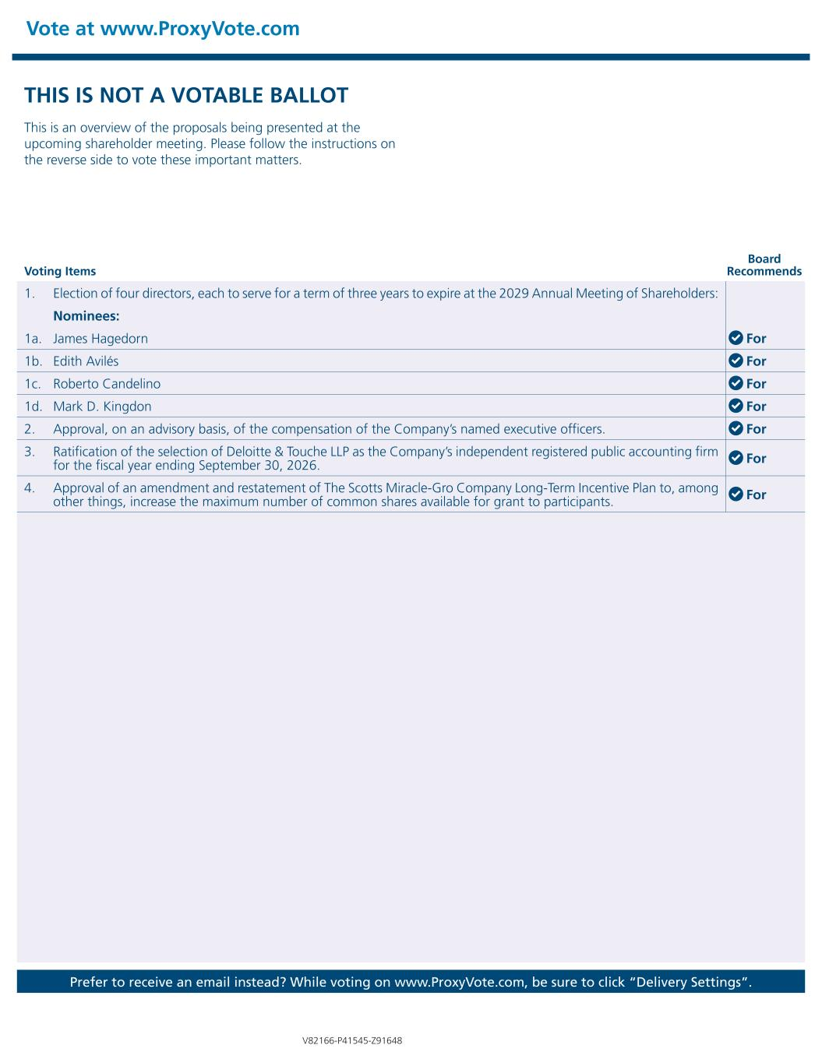
Vote at www.ProxyVote.com Prefer to receive an email instead? While voting on www.ProxyVote.com, be sure to click “Delivery Settings”. Voting Items Board Recommends V82166-P41545-Z91648 THIS IS NOT A VOTABLE BALLOT This is an overview of the proposals being presented at the upcoming shareholder meeting. Please follow the instructions on the reverse side to vote these important matters. 1. Election of four directors, each to serve for a term of three years to expire at the 2029 Annual Meeting of Shareholders: Nominees: 1a. James Hagedorn For 1b. Edith Avilés For 1c. Roberto Candelino For 1d. Mark D. Kingdon For 2. Approval, on an advisory basis, of the compensation of the Company’s named executive officers. For 3. Ratification of the selection of Deloitte & Touche LLP as the Company’s independent registered public accounting firm for the fiscal year ending September 30, 2026. For 4. Approval of an amendment and restatement of The Scotts Miracle-Gro Company Long-Term Incentive Plan to, among other things, increase the maximum number of common shares available for grant to participants. For

